**CAT 2**

**Question Bank**

**ADA**

Q1. Analyse the need of Dynamic Programming in multistage graphs with example.

Q2. Examine the travelling salesman problem and discuss how to solve it using dynamic programming?

Q3. Inspect and solve for the optimum cost using matrix chain multiplication of A 4x5, B 5x7 , C 7x3 , D 3x2 and E 2x7 matrices.

Q4. Apply dynamic programming to find out the optimal sequence for the matrix chain multiplication of A 4x10, B 10x3 , C 3x12 , D 12x20 and E 20x7 matrices.

Q5. Explain (0/1) knapsack problem and fractional knapsack problem.

Q6. Explain the Dynamic Programming (DP) Algorithmic Paradigm? List a few problems which can be solved using the same.

Q7. Examine and solve the following 0/1 Knapsack Problem using Dynamic Programming. There are five items whose weights and values are given in following arrays. Weight w [ ] = {1,2,5,6,7} Value v [ ] = {1, 6, 18, 22, 28}. Show your Equation and find out the optimal knapsack items for weight capacity of 11 units.

Q8. solve for the shortest path using multistage graph method using dynamic programming by taking an example.

Q9. Define a B-Tree. Show the result of inserting the keys F, S, Q, K, C, L, H, T, V, W, M, R, N, P, A, B, X, Y, D, Z, E in the order to an empty B-Tree of degree 3

Q10. Apply dynamic programming to find out the optimal sequence for the matrix chain multiplication of A 4x10, B 10x3 , C 3x12 , D 12x20 and E 20x7 matrices.

Q11. Find the maximum keys in the case of a B-tree of order 4 and of height 3.

Q12. Solve the Travelling Salesman problem Dynamic programming with example.

Build the maximum profit using dynamic method by considering the Knapsack capacity W=9, w = (3,4,5,7) and v=(12,40,25,42).

Q13. Interpret the need of Dynamic Programming over Recursion. Take suitable example to illustrate the above need.

Q14. Compare the divide and conquer and dynamic programming problem solving approaches.

Q15. Create a Binomial Heap using suitable example.

Q16. Identify the use of convex hull problem and explain it with the help of a diagram.

Q17. Explain a Red Black tree.

Q 18. Create a Red Black tree given input 2, 1, 4, 5, 9, 3, 6, 7.

Q 19. Explain B tree.

Q 20. Explain binomial heap.

Q 21. Discuss how Fibonacci heap is different from binomial heap?

Q 22. Solve the Travelling Salesman problem using Dynamic Programming problem for the following graph and find the shortest path  
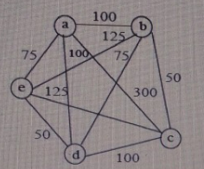

Q 23. Examine and create a B-Tree of order 4 by inserting following key values: 6, 5, 22, 9, 2, 13, 3, 7, 11, 12, 4, 8

Q 24. Solve the below graph for the shortest path using multistage graph method with dynamic programming approach.  
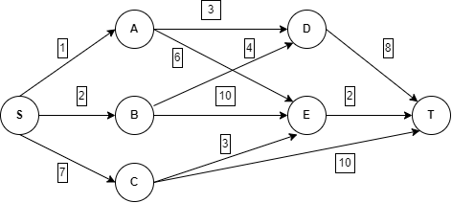

Q 25. Solve the following instance of 0/1 Knapsack problem given the knapsack capacity is M=5

| **Objects** | 1 | 2 | 3 |
| --- | --- | --- | --- |
| **Profit** | 5 | 3 | 4 |
| **Weight** | 3 | 2 | 1 |

| Q 26. 4 matrices M1, M2, M3, M4 of dimensions’ p *x* q, q *x* r, r *x* s, s *x* t respectively can be multiplied in several ways with different number of multiplication because of associative property. If p=10, q=100, r=20, s=5, t=80. Then what will be the minimum number of multiplications required to multiply M1,M2,M3,M4? |
| --- |

Q 27. Convex Hull of a set of points, in 2D plane, is a convex polygon with minimum area such that each point lies either on the boundary of polygon or inside it. Now given a set of points the task is to find the convex hull of points.

Q 30. Discuss and derive an equation for solving the 0/1 Knapsack problem using dynamic programming method. Design and analyse the algorithm for the same.

Q31. Construct a Red Black tree by inserting 9,19,30,15,16 and 27 into an initially empty tree and also delete 15,16 and 30 from the tree.

Q32. Obtain the solution to knapsack problem by Dynamic Programming method n=6, (p1, p2,...p6)=(w1,w2,...w6)=(100,50,20,10,7,3) and m=165.

Q33. Explain the Dynamic Programming (DP) Algorithmic Paradigm? List a few problems which can be solved using the same.

Q34. Differentiate between Greedy approach and dynamic programming problem solving approach.

Q 35. How Red-Black tree is different from B-Tree. Explain with example.

Q 36. Solve the below graph for the shortest path using multistage graph method with dynamic programming approach.

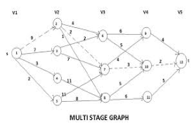

Q37. Solve the below graph for the shortest path using multistage graph method with dynamic programming approach.

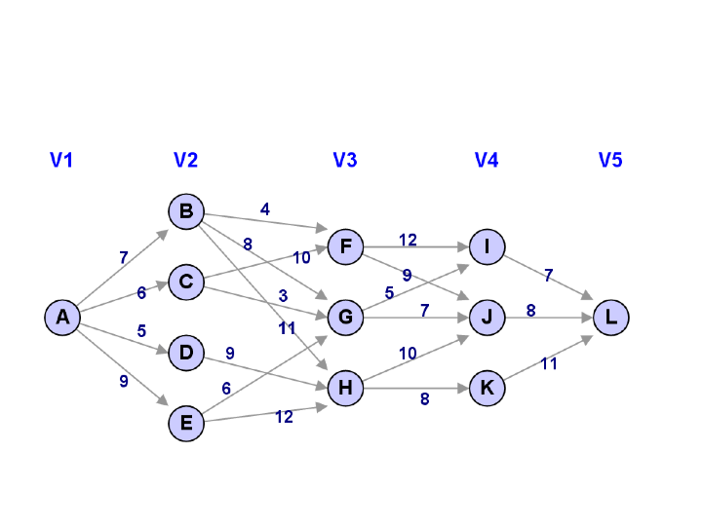

Q38. What is B-Tree? Explain it with its example and rules.

Q39. What is the importance of Convex Hull. Explain with proper example.

Q40. Write down the problem statement of TSP. Explain it with the help of an example.